Çankaya University
Department of Computer Engineering
CENG 505 Parallel Computing Take Home Exam

Date: 06/01/2020
Instructor: Asst. Prof. Hüseyin Temuçin
Name and Surname : ………………………………………
Student Number : ………………………………………
Q1(30p) | Q2(40p) | Q3(30p) | Bonus(15p) | Total

Q1) (30p)
- What is MIMD ? Example a real-world application for MIMD architecture
- What is SIMD ? Example a real-world application for SIMD architecture
- What are distributed memory and shared memory architectures?
  - Example a project scenario which is suited for distributed memory (if your number is odd)
  - Example a project scenario which is suited for shared memory (if your number is even)
Q2) (40p)
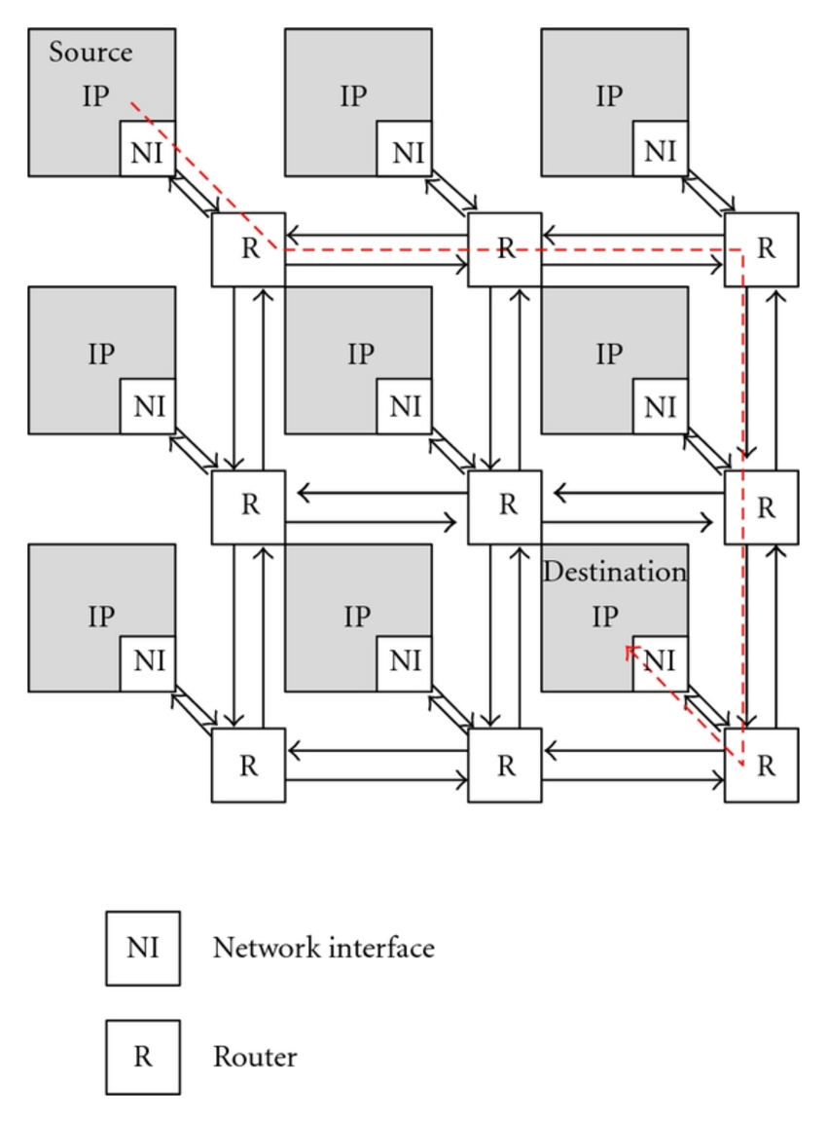 | The left figure illustrates a direct network topology for a 9-computer architecture. Using message-driven structure for given architecture  a. Develop a barrier algorithm (if your number is unique)  b. Show that the barrier algorithm you have developed works in the same topology as 4x4 (if your number is unique)  c. Develop an All-reduce algorithm (if your number is even)  d. Show that the all-reduce algorithm you have developed works in the same topology as 4x4 (if your number is even)

Q4) (30p)
- Describe Foster’s methodology steps which are given below:
- Partitioning.
- Communication.
- Agglomeration or aggregation.
- Mapping.
- Apply this methodology for a matrix multiplication algorithm,
i . For shared memory (if your number is even)
ii . For distributed memory (if your number is odd)

Bonus) (15p)
Imagine giving you $ 100,000 if you pass this lesson (it really won't happen :))
1. How would you develop a project with this money? What layers would your project consist of?
2. What kind of benefits did you learn in this lesson bring to your project design?

